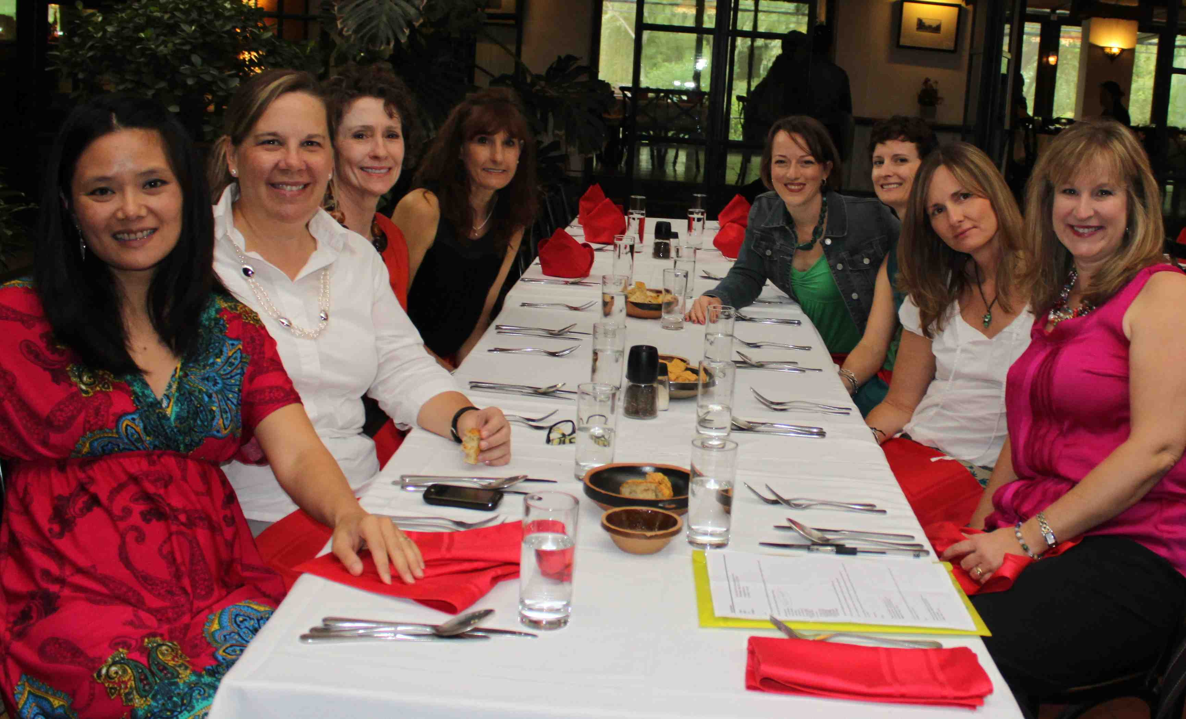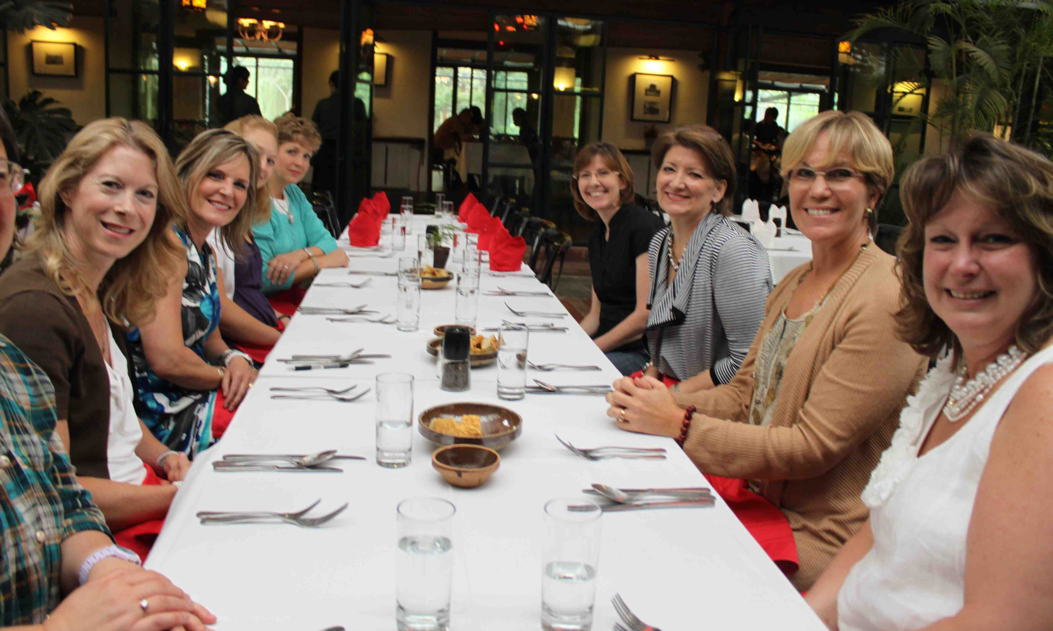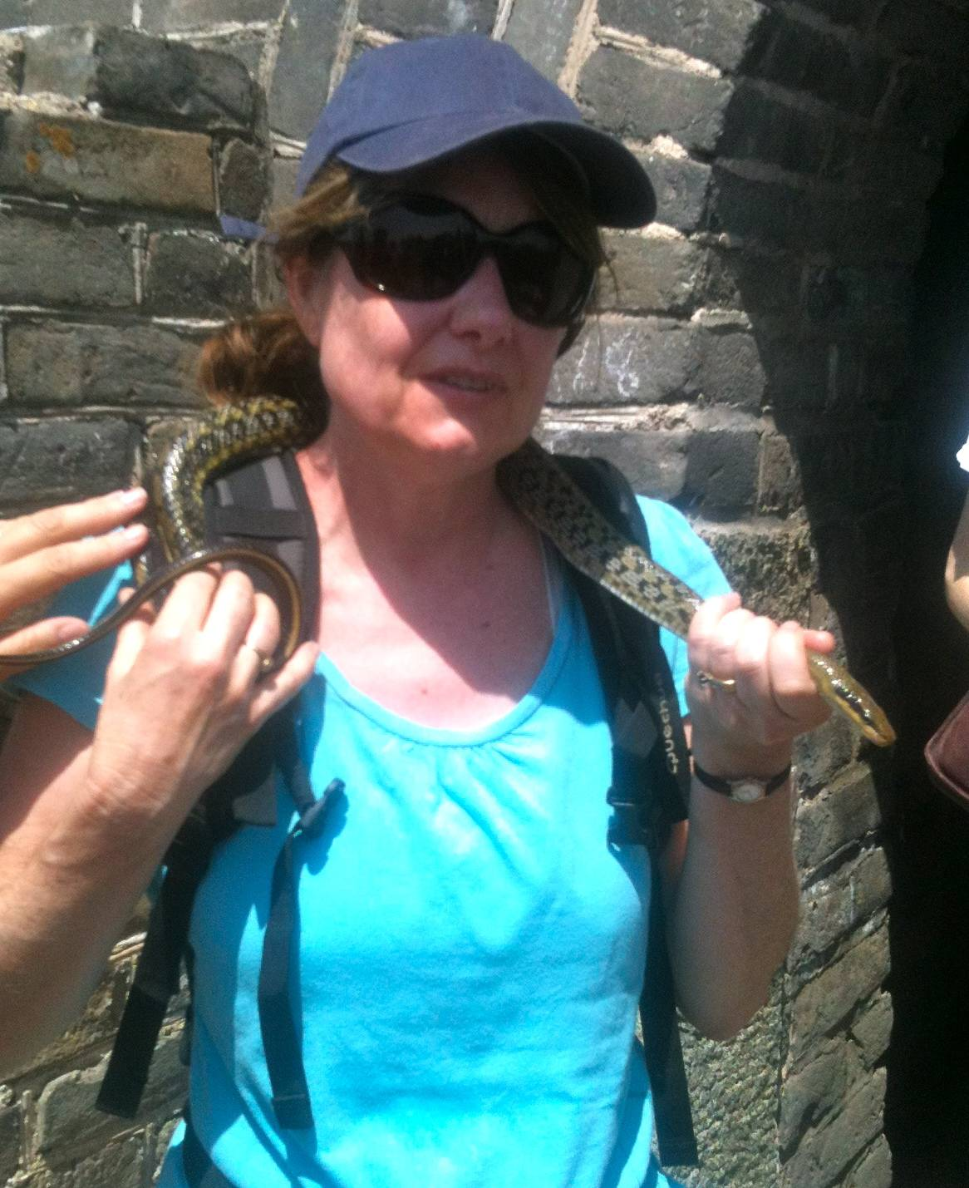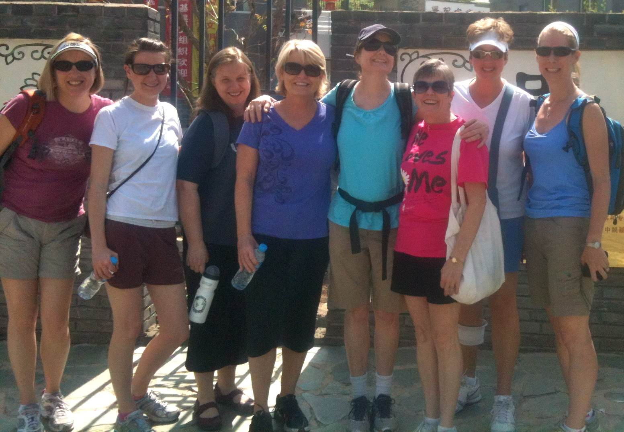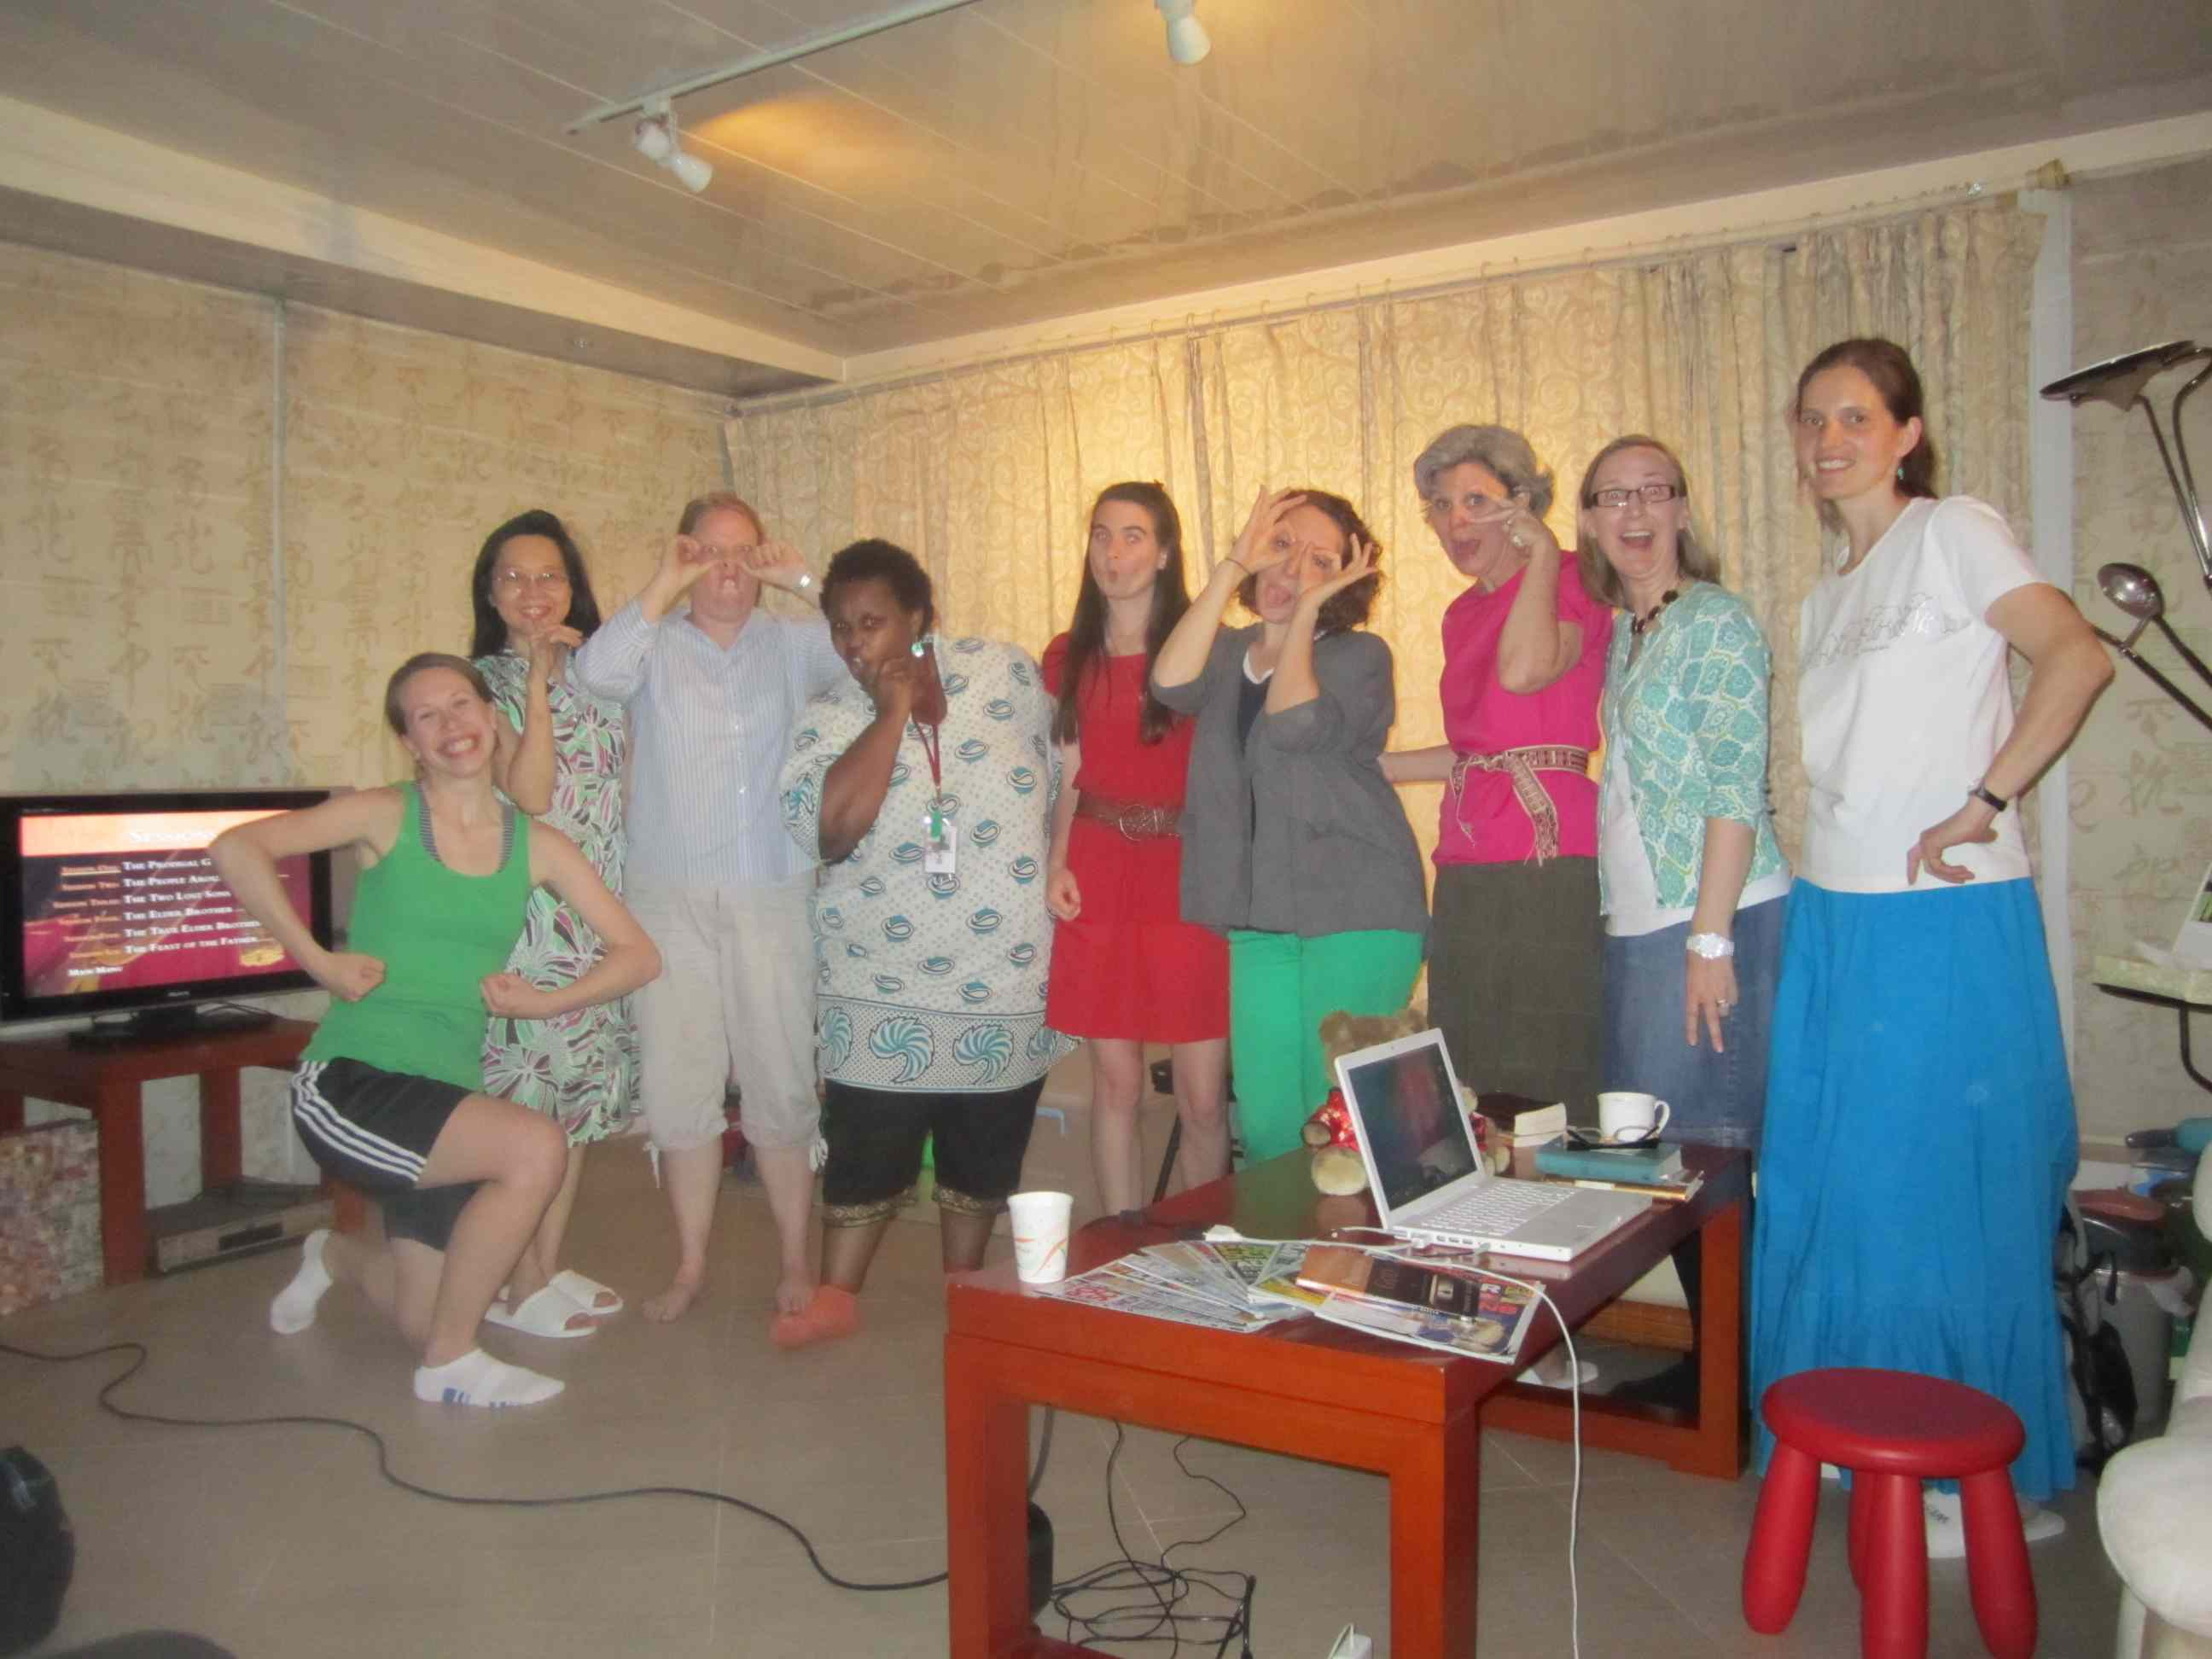

Great Wall Mutianyu Hike . . .

Many CCC Ladies came to say ‘farewell’ over lunch at the Orchard to our Sisters leaving this summer. It was a time of sharing and tears as well as a great opportunity to steal a few precious moments together. We thank Him for the fellowship that we have been privileged to experience and also for unforgettable memories. Thank the Lord for Email and Skype! We will miss you sweet Sisters but we are always together in Spirit as the body of Christ. Bon Voyage! Go and be Light to the world!

The Ladies who attended the hike out at the Great Wall in May met with an unexpected visitor on their trip! Kathryn Westberg, our resident Snake Whisperer (though I thought dogs were her specialty) had the courage to have a close encounter with this dear fellow pictured above. I’m not sure that the rest of the group were as enthusiastic however. This aside, after a solid hike, a well-earned lunch followed at the School House Restaurant. I wonder what the next surprise is going to be on our outing calendar? Stay tuned for more dates! A BIG Thank you to Wendy Beeman for organizing this event!

GOOD BYE LUNCH

Who said anything about Snake Handling?

bible study group SPOTLIGHT . . .

Twelve women gathered to study the Parable of the Lost Son over six weeks in April and early May, in Shunyi homes. We used Timothy Keller's book The Prodigal God to specifically look at the people around Jesus, the two lost sons, the elder and the younger brother's roles, the true elder brother being Christ, and the Feast of the Father.  The study was held at five different homes over the course of six weeks, with different women hosting, leading and providing refreshments each time. Women grew in their knowledge and application of Jesus' parable of the lost son as well as seizing the opportunity to use their gifts to bless others through hospitality and teaching.  (Evelyn McCulloch)

**WANT TO GET CONNECTED?**

Contact Iris Lowder for information about groups on irisnprc@securenym.net

‘Dear friends, since God loves us that much, we surely ought to love each other. No one has ever seen God. But if we love each other, God lives in us, and his love has been brought to full expression through us.`

NLT 1 John 4:11-12

Welcome to our final Newsletter before the summer break. In this edition we share about what CCC Women have been busy doing throughout May as well as information on how to stay connected for sisters who are staying in Beijing during the summer break. We pray for a safe and blessed time for all of you and a blessed and smooth transition for our sisters who are moving away. We’ll miss you!!!

June 2012

**G E T C O N N E C T E D A T C C C !**

Time for Reflection . . . and a cup of coffee!

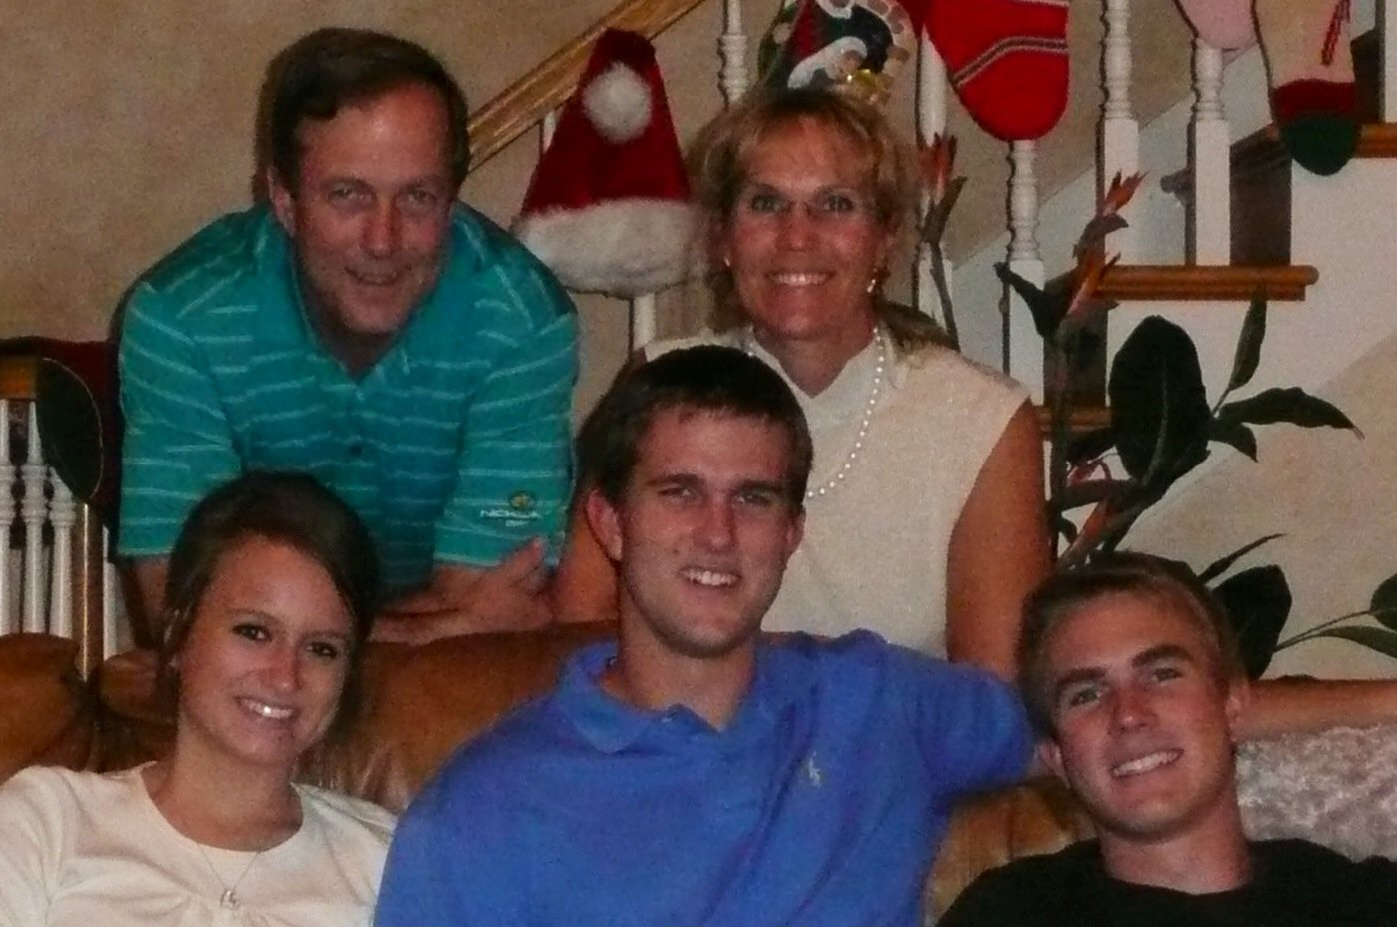

**Getting to know you …**

We are Bruce and Nayree Davis from Florida, USA.  We were here just 24 hours, before we got to come to our first Sunday service at CCC!  Your opened arms welcomed us and we thank you for the many blessings we have already received in a few short months.  We came to Beijing like many have for work related reasons.  Bruce is a developer in the golf industry.  I set aside my job as a certified pharmacy technician to join Bruce, who has been working here already most of the time for the last two years.  God is so good all the time, He has given us this wonderful experience in China of empty nest renewal for our marriage.  We leave our family back in Florida which includes our two handsome sons, Andrew (24) and Alex (22).  We also miss our 12 year old lab, Bailey.  We have parents in California and Minnesota, so all of our stateside visits will be very busy.  Bruce likes to go to BD Flower Market after church to check up on all of the fish aquariums, as fish tanks, and fishing are his hobbies.  I love to learn new things such as Mandarin, visit with the elderly, cook and be involved in Bible studies.  For instance, this summer's women's study, The Twelve Steps:A Spiritual Journey will begin June 5th, at 10:30am for eight weeks.  In this study, we will share our experience, strength and hope using the healing process of the Twelve Steps applied with a Biblical, Christian world view.  This will be a wonderful small group experience over the summer, a chance for renewing, maturing or experiencing for the first time, the discipline and obedience of a Christ-like spirit.

Bruce and I feel at home right here in Beijing without hesitation or reservation because of the fellowship of CCC.  Thank you all for being here for newcomers such as ourselves!

In His mercy and grace, Nayree Davis

**www.capitalcommunitychurch.org**

UPCOMING EVENTS!!!! SAVE THE DATE!

**Summer Study:** We will be offering an eight week summer bible study for women entitled "The Twelve Steps: A Spiritual Jouney." The study is about surrender, wholeness, God's grace and healing. It will begin on Tuesday, June 5th from 10:30 am - 12:00 pm at the home of Nayree Davis (A127 Beijing Riviera).  Workbooks are 90RMB.  If you are interested in participating in the study, contact Nayree ([bnaadavis@yahoo.com](mailto:bnaadavis@yahoo.com), 135 2257 8548).

Tasty Meal Ideas!

**The CCC Cookbook Team** has assembled a collection of recipes from the cooks at Maria's House of Hope and the cookbooks will be available Sunday for 60RMB. All proceeds will go to Maria's House of Hope. They are available Sunday or you can contact Angie Schleiff ([mascheiff@gmail.com](mailto:mascheiff@gmail.com)).

**Do you have a leading to serve in Women’s Ministry?**

We have two positions that are in need of filling. A Special Events Team Leader who would co-ordinate conferences, retreats, spring banquet, etc and a Missions Team Leader who plans and implements mission projects for women to be involved in throughout the year.

Should you feel led to fill either of these positions, please contact Rhonda Ausk at [rhonda@auskinternational.com](mailto:rhonda@auskinternational.com). Many hands make light work!

Bruce Edstrom’s visit to CCC these past few weeks put our focus on the story of our lives and the story of the Cross. All stories have drama. That’s what makes them stories. As Bruce reminded, the drama of our lives comes from a deep place – the fact we are made in the image of God and yet born depraved. That makes for ups and downs. And that makes for suffering and pain. Honestly, I prefer the ups. The reality of suffering in our lives creates a real problem for me because I hate suffering. No, I fear suffering. That fear motivates me. Unrighteously, I know. I’m thankful to Bruce for reminding me not to push myself, or others out of that place called suffering too quickly. Jesus is the true healer. Not our brilliant plans, responses, tactics, strategies, and resources. Fearful of suffering, I turn from the early signs of pain with planning, individual strength, and relational withdrawal. I can do the same in my relationships as too often I offer hurting friends very practical plans for saving and response. It is our natural tendency to not want to suffer, to not want to linger in that hurt for long. But, when we push away from suffering with our own strength, we then miss the beautiful, transforming and life-giving blessing of receiving Jesus as the perfect healer in the midst of pain. I hope that as Bruce’s time here fades from memory, we’ll keep his encouragement in our hearts: May we remember that our lives are God’s story; that there is no surprise ending, just a perfect ending; and may we slow down in our words and acts of self- and other-healing so that instead the works of God might be displayed in the way He heals us. (Shannon Allen)

**CONTACT US!**

**Director of Women’s Ministries:** Iris Lowder: [irisnprc@securenym.net](mailto:irisnprc@securenym.net)

Ph: 13811387564

**Events and Team Co-ordinator:** Rhonda Ausk

[rhonda@auskinternational.com](mailto:rhonda@auskinternational.com)

Ph: 15611665514

**Mandarin Women’s Leaders:**

Joanne Qian

[Jqian2001@yahoo.com](mailto:Jqian2001@yahoo.com)

Rosie Yeo

[rlowyeo@yahoo.com](mailto:rlowyeo@yahoo.com)

**Specific Prayer Request?**

Cheryl Claudio

[Vncplus3@yahoo.com](mailto:Vncplus3@yahoo.com)

Ph: 13811951477

**Need Support & Encouragement?**

Rachel Heffield

bjexpatcounselor@gmail.com

**Wish to help with Special Events?**

Is this you?

**Missions:**

Is this you?

**Communications:**

Eleanor Lyons

eleanor.lyons@me.com

**Want to be involved in Drama?**

Kathryn Westberg

[kbwestberg@hotmail.com](mailto:kbwestberg@hotmail.com)

**Do you have a talent in Church Enhancement?**

Ann Locher

[tennismomlocher@gmail.com](mailto:tennismomlocher@gmail.com)

**Bible Study Fellowship Teaching:**

Angie Schlieff

maschleiff@gmail.com