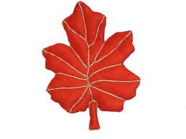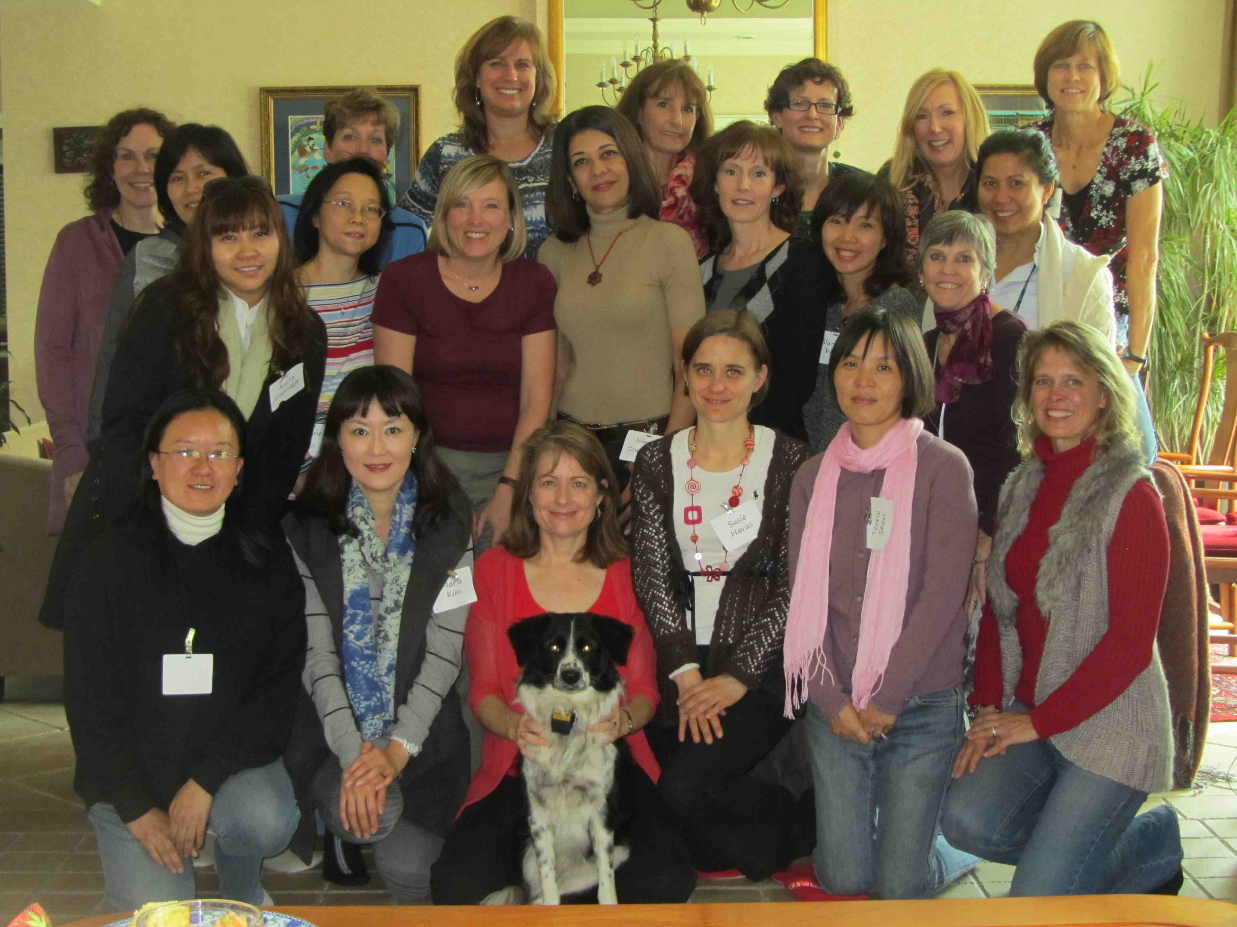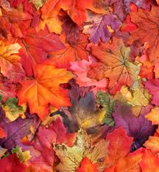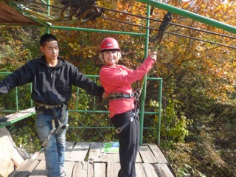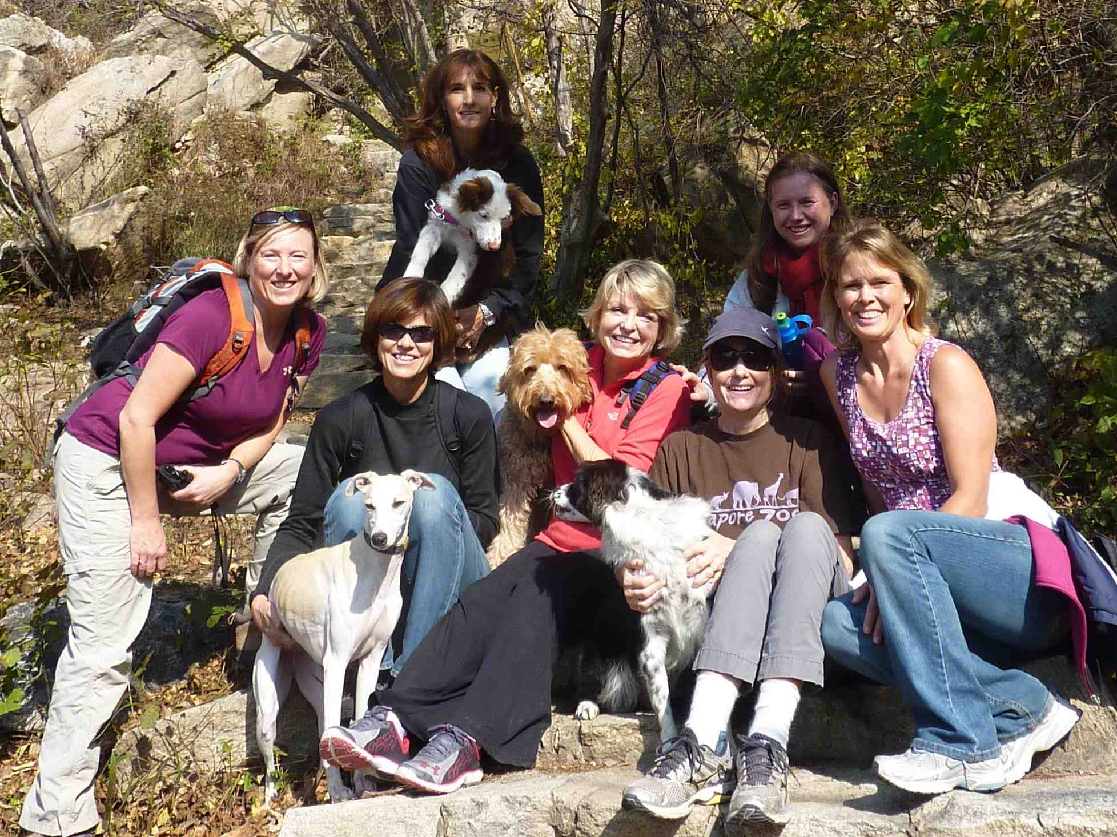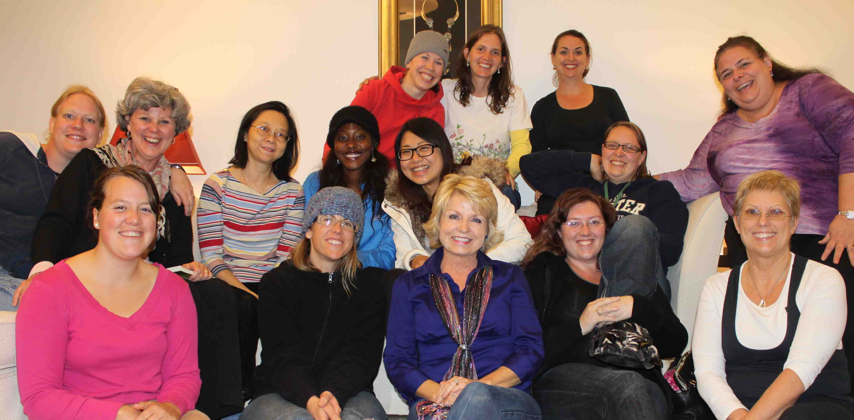

**May God bless you! 神祝福你 shén zhù fú nǐ**

Kathryn Westberg hosts a bible study every Tuesday afternoon from noon to 2:30pm in Yosemite.  This semester we have finished up our study of Gary Thomas' Sacred Marriage and are starting a 6-week study by Kay Arthur, Priscilla Shirer and Beth Moore called Faithful, Abundant, True.  The collaboration is part of LifeWay's Deeper Still events.  We first listen to the teachers and then the workbook helps us to unpack the messages through questions and Scripture references.

We have a great time in fellowship with Kathryn and Eleanor leading small group studies followed by prayer for our bible study ladies.  (**Kathryn Westberg**)

Brrrr .. winter is around the corner and it’s not my favorite season of the year because it gets *so* dark and cold. Yet I never cease to be amazed at how beautifully God transforms the seasons from one into the next and how He fills each season with colorful and rich treasures, like fall leaves and snow! Now is the time to celebrate His abundant provision! The harvest is in and it is time to give thanks to our Great God for our daily bread and more importantly for the bread that gives eternal life. Jesus said, “I am the bread of life. Whoever comes to me will never be hungry again” (John 6:35 NLT). Come to Him, feast on His word continuously, be satisfied and be thankful! Happy Thanksgiving!!

There are so many nice things to do in Beijing… It would be easy to fill up my whole schedule besides family and housework with activities every week…

The first few months in Beijing I felt like having no time for bible studies and instead spent most of my free hours learning Chinese. It is always tempting to set priorities differently.

Going to Rhonda’s bible studies has been a very good decision. The more I spend time in his word and in fellowship, the more my heart is filled with joy. Being with great likeminded women is very encouraging for me. On top of that I always come home in a good mood that even held when I discovered my brand new shoes had been chewed up by our dog during my absence ☺.

In the first round of bible study we talked about trials. As I had been going through some health issues myself, I sometimes doubted the strength of my faith. But someone looked deep into my eyes and reminded me that that was not the way God works. That evening we prayed together as a whole group for each other and just a few days later God answered. The doctor finally found the root cause and shortly after that I had surgery. A dear woman of our group spent one whole day besides my bed. Knowing the ladies were praying for us was so strengthening.

Giving more attention to God, walking closer to him, is never wrong! He helps me to focus on important things in my life, to choose the right path. That’s why I can’t wait for the following studies… by **Mirjam Erhard (**pictured in the back row 2nd from the left)

Adventure !!

There were 7 women and 4 dogs that went to Mt. Yunmengshan National Forest Park.  We hiked through beautiful scenery while we visited with each other and watched the dogs playfully run along the path. A beautiful scenic rock was found to share our sack lunches whilst looking out over God's creation. We then hiked back down the mountain and added a zip line to top off the adventure!

Take a look at ‘Upcoming Events’ overleaf for the next opportunity to get connected!

**Bible Study News!**

**WANT TO GET CONNECTED?**

Contact Iris Lowder for information about groups on irisnprc@securenym.net

November 2012

**G E T C O N N E C T E D A T C C C !**

‘Dear friends, since God loves us that much, we surely ought to love each other. No one has ever seen God. But if we love each other, God lives in us, and his love has been brought to full expression through us.`

NLT 1 John 4:11-12

Time for Reflection . . . and a cup of coffee!

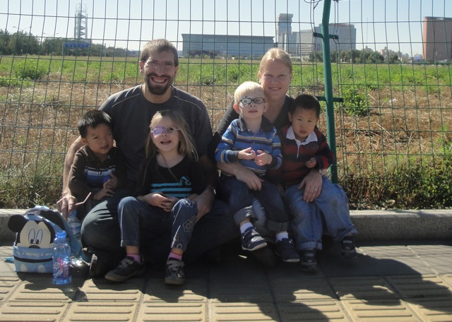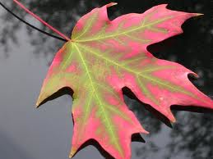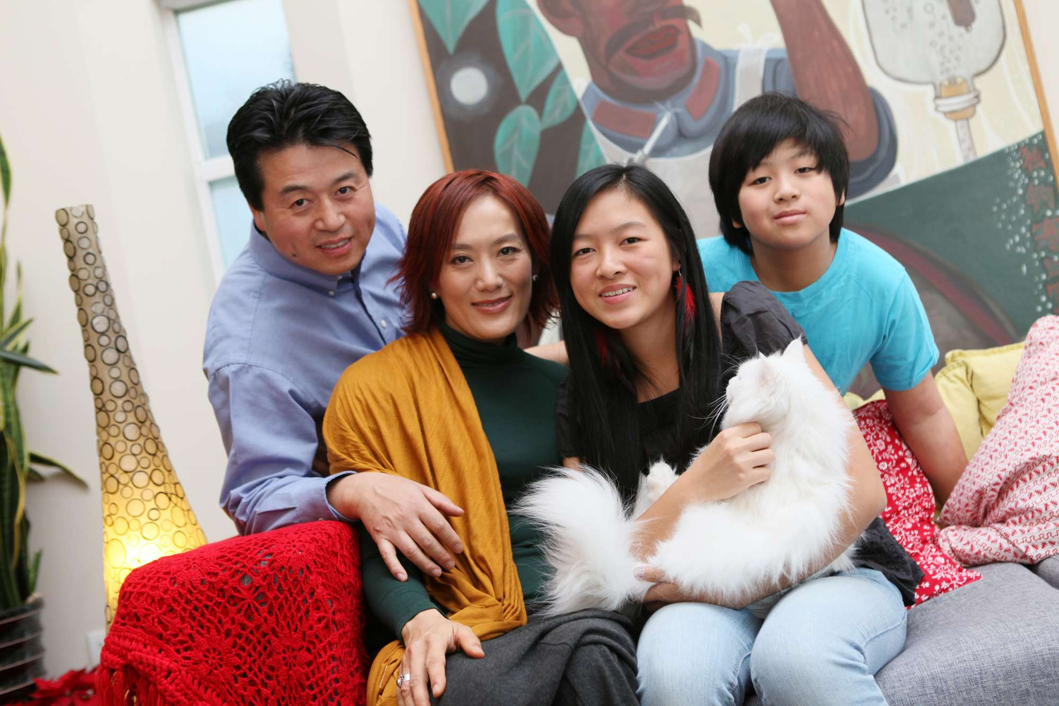

UPCOMING EVENTS!!!! SAVE THE DATE!

**Nov 30** - Start your Christmas shopping early with a trip to the **Pearl Market** and an inexpensive but yummy **Chinese lunch**. Meet at 9:30am at Pinnacle Plaza Starbucks.  Back by 3pm. If you have a car available to help with transport, please let me know. Also, if you would like me to schedule an evening activity because daytime doesn't work for you, contact me at [wendybeeman@hotmail.com](mailto:wendybeeman@hotmail.com).

**Dec 2 - Women’s Christmas Lunch** coming up in December. Exact details to be published in the bulletin!

**“Being Thankful”**

Rhonda asked me to write an article on being thankful for this month’s newsletter because she said she figured I had a lot to be thankful for this year. And it’s true! In the last year we have added two beautiful boys to our family through adoption (bringing our household total to four preschoolers). We love the home that we have been blessed with, and in our neighborhood we have several wonderful friends. If my husband could be doing any job in the world, he would be doing exactly what he is doing right now. These were all the things that came to mind as I thought about what I had to be thankful for.

As I was mentally making my list, it reminded me of all the times over the years we have had Thanksgiving parties for the Chinese university students that we worked with. Part of our party always included giving them an opportunity to list things that they were thankful for, and inevitably their lists included such common things as: My family, My friends, My studies. Very few of these students were believers in Jesus, but it occurred to me that, even without God in their lives, their lists looked almost identical to mine. And it got me to thinking that if my list was no different than a non-Christian’s list, then something was wrong. So here is my new list of things that I am thankful for.

I am thankful that in bringing Isaac and David into our home, God gave me way more than I can possibly handle. Every day the level of needs and demands are overwhelming and I am completely unable to handle it. And because of that, much of my former pride is revealed as the emptiness that it is, and I am driven every morning to cling to the promises that His mercy is new every morning and He is the one who will meet both the needs of myself and my children. And on the days when I remember to look to Jesus my house is full of such redemptive chaos.

I am thankful not only for a wonderful house to live in, but I am also thankful for the leak in the basement and the line of sticky mystery substance that covers all my walls at about finger level for three year olds. Because with Jesus in my life I don’t have to live enslaved to my stuff. So many people *live* for their possessions, but I live for Christ so it doesn’t have to destroy me when everything isn’t perfect or as good as the neighbors.

I am thankful for friends who are not only friends but also brothers and sisters in Christ who point me to Jesus.

I am thankful that in this current season of joy and fruitfulness in our work, God has graced us with the ability to see how past seasons of frustration and fruitlessness have all been a part of the journey that has brought us here. And I am thankful for the reminder that brings; to not lose hope and heart, when in the future, unexpected turns and failures bring us back to another place, where all is not what we wish it would be.

These are the things that I am truly thankful for in this season where we are reminded to give thanks. It’s too easy to settle for giving thanks for things that don’t cost anything. But I encourage you to press deeper to the more hidden and precious places of thankfulness. That is where real joy and life are to be found – in truly being thankful. **Rebecca Staege**

Ladies of CCC,

*Looking for something meaningful to do each week?*

**Here is an opportunity to SERVE together WITH other CCC women!**

**Amazing Hands Foster Home** (run by our very own Amy Pu!) is in need of some volunteers to help hold and interact with babies and toddlers!  Amazing Hands is a privately run foster home that takes in special needs children from government run orphanages in rural parts of China and brings them to BJ for surgery, rehabilitation, therapy, etc until they are adopted.

Please consider committing 1 – 2 hours each week.  It could be the BEST part of your week! Here are the specifics:

**Where:**  Amazing Hands, located in Maquanying Village, near Beijing Riviera

**When:**  weekly --- current needs areTues – Fri, 9 – 11AM, or Mon, Wed or Fri 3:30 – 5:30PM.

You can sign up for one or more timeslots.  If you cannot stay for the whole two hours,1 – 1.5 hours is fine.

**How:** email Beth Canterberry at [njheeler@aol.com](mailto:njheeler@aol.com)  and let her know your first and second choice of times.  Up to four people per time slot can be used (they have 14 children!), so signup with a friend if you like!  Beth will get you connected with Amazing Hands so that you can arrange a first visit.

**You are BLESSED to be a BLESSING to others in Beijing!**

**Getting to know you …**

**大家好！(da jia hao!)** I'm Joanne Qian and am from Hangzhou, a beautiful city located in Southern China. In 1992, I married James and later moved to California. This year we celebrated our 20th anniversary! We have two children, Stephanie (16 years old), and Christopher (12 years old). We moved to Beijing in 2004 and have been a part of the CCC family since then. 20 years ago, I left China with just a small suitcase with no intention of ever returning to China. I felt that I was heading towards a brighter future in the "Land of Opportunity" and never imagined that I would one day return to China. In America, James and I worked hard to earn "everything" over a period of 10+ years: respectful careers, nice cars, a beautiful home, two lovely children, and two dogs. In 2000 I became a believer and in 2004 I was faced with a choice to give up "everything" and follow my husband back to China. It was a very difficult decision. However, the elders in my church encouraged me to follow my husband, they read me the story of Abraham leaving his homeland and told me that at least I knew my destination. :-) Afterwards, the whole church blessed me.

Looking back at the past eight years in Beijing, I realized the blessings my family received are beyond imagination. God actually rewarded our family with Himself--James, Stephanie, and Christopher were all baptized in CCC and now God is truly the Lord of our home!

**www.capitalcommunitychurch.org**

**CONTACT US!**

**Director of Women’s Ministries:** Iris Lowder: [irisnprc@securenym.net](mailto:irisnprc@securenym.net)

**Events and Team Co-ordinator:** Rhonda Ausk

[rhonda@auskinternational.com](mailto:rhonda@auskinternational.com)

**Mandarin Women’s Leader:**

Joanne Qian

[Jqian2001@yahoo.com](mailto:Jqian2001@yahoo.com)

**Specific Prayer Request?**

Nayree Davis

bnaadavis@yahoo.com

**Need Support & Encouragement?**

Rachel Heffield

bjexpatcounselor@gmail.com

**Wish to help with Special Events?**

Anna Yuet Wah Leung

annawleung@yahoo.com

**Missions:**

Beth Canterbery

[njheeler@aol.com](mailto:njheeler@aol.com)

**Communications:**

Eleanor Lyons

eleanor.lyons@me.com

**Want to be involved in Drama?**

Kathryn Westberg

[kbwestberg@hotmail.com](mailto:kbwestberg@hotmail.com)

**Do you have a talent in Church Enhancement?**

Ann Locher

[tennismomlocher@gmail.com](mailto:tennismomlocher@gmail.com)

**Bible Study Fellowship Teaching:**

Angie Schlieff

maschleiff@gmail.com