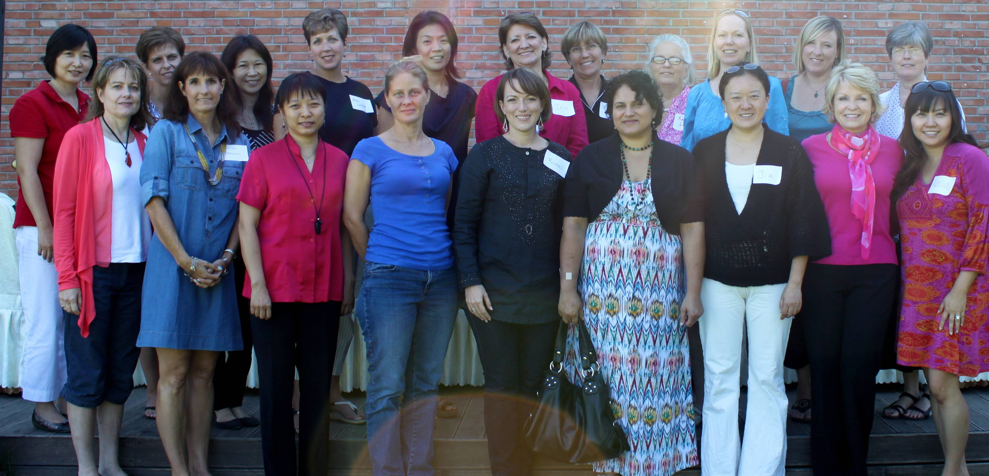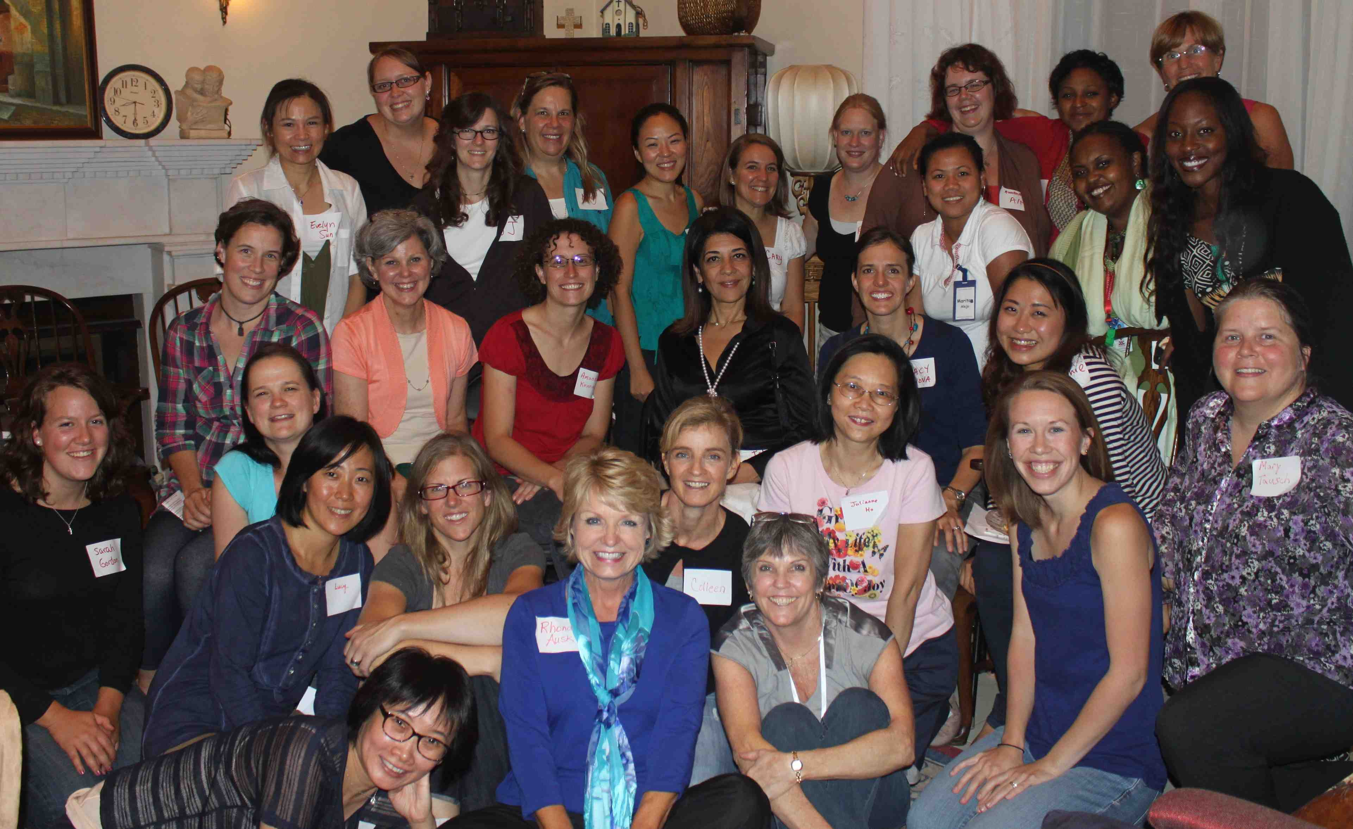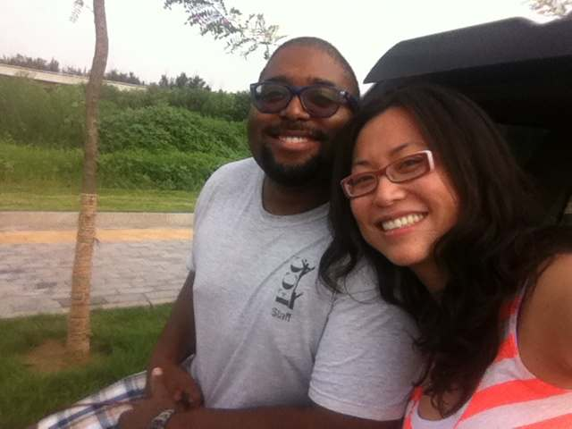

**It’s not too late! New Studies starting in October!!**

A new 6-week study called Faithful, Abundant and True by Kay Arthur, Priscilla Shirer and Beth Moore commences on **23rd October**. There are currently 16 of us, but we welcome new members at any time. If you would like more information please contact group leader Wendy Beeman at [wendybeeman@hotmail.com](mailto:wendybeeman@hotmail.com).

This same study will also be available on the same day at Kathryn Westberg’s home. For more information please contact Kathryn at kbwestberg@hotmail.com.

**Spiritual Steps Bible Study** is a small women’s group, two-semester study in which we examine the sin in our life using Bible teachings. We learn to break many types of undesirable sin habits with the spiritual steps by identifying our sins, (such as fear and pride) confessing our sins, and accepting the loving healing of Jesus Christ in our life. Please join us Thursdays at 9:30am at the home of Nayree Davis in Beijing Riviera. Contact Nayree for more info: bnaadavis@yahoo.com

There was a determinable excitement just to get there: women saying, "I'm going, let's go together," carpooling, calling each other "how do you get there?", arrival, smiles on new faces and old friends. Once there, Iris encouraged us to keep our hearts and thoughts open to God and people while we opened our mouths to savor the chocolate, the cake and the cookies. The dessert night was a SWEET gift for our hearts, souls, and taste buds!

(By Tracy Vilanova, pictured 3rd row 3rd from the right))

My name is Jia Besco, and I came to the Women’s Lunch to be more involved with CCC. I was born and raised in Beijing. I went to the U.S. for higher education; where I met my husband Robert Besco. We have three children now. I am a full-time mother, and a part-time economics teacher at Tsinghua University. I was very happy to know so many sisters in Christ at Friday’s lunch. (I joined Kathryn’s bible study group on the following Tuesday.) I was emotionally touched by the stories Iris shared with us. The Ayi story refreshes my memory of Godly actions I have experienced in my life. I am aware of the blessings God showered upon me before I knew God. And now, his blessings are more of a reality as I walk with him. I understand that everything happens according to his plan. My involvement with CCC is evidence of his ever present guidance in my life. I am overjoyed with my newfound Christian fellowship he has led me to. (Jia is pictured in the 1st row, 3rd from the right)

Thank you Lord,

Jia

**WANT TO GET CONNECTED?**

Contact Iris Lowder for information about groups on irisnprc@securenym.net

**DESSERT !**

**LUNCH !**

Yesu ai ni！ 耶稣 爱 你！ Jesus Loves You! How wonderful to be able to say or hear these words and understand. The Lord seeks to have us draw near to him and He will draw near to us! (James 4:8) and this is what we do every time we come together in prayer, worship, study and fellowship. September has been full of opportunities for ladies to draw near to God and we encourage you to get plugged into what CCC has to offer if you have not already done so. Jesus loves you! Draw near and be blessed!

**Getting to know you …**

*"Hello, ladies! My name is Joyce Jackson, wife of Joe Jackson, the Youth Guy here at CCC. I was born in Hong Kong, raised in Vancouver, Canada. As with many younger Hong Kongers, although I am a Chinese by blood, I didn’t know much about China at all. The desire to live and to serve amongst the Chinese people has brewed in my heart for quite some time, but I never had a chance to make the leap until fall of 2008, just after the Olympics. The day that I left home, I had no idea what God had in mind for me in China. I knew for sure there’s adventure ahead, but never in my dreams have I imagined a life so fun, full, and awesome! Since 2008, I’ve studied and graduated, worked at a foster home for blind orphans (the best place on earth), met the man of my dreams and married him in 2011 right here at CCC! Currently, most of my time is spent on learning how to be a better wife and working alongside Joe in the youth arena. I love the community here at CCC and I praise God for bringing me here. If you are new, I pray that you will find a community here just like I did, a place where you can grow deeper in faith and friendship with fellow believers. Talk to Iris or the women who handed you this newsletter - we’ll get you plugged in!"*

October 2012

**G E T C O N N E C T E D A T C C C !**

‘Dear friends, since God loves us that much, we surely ought to love each other. No one has ever seen God. But if we love each other, God lives in us, and his love has been brought to full expression through us.`

NLT 1 John 4:11-12

Time for Reflection . . . and a cup of coffee!

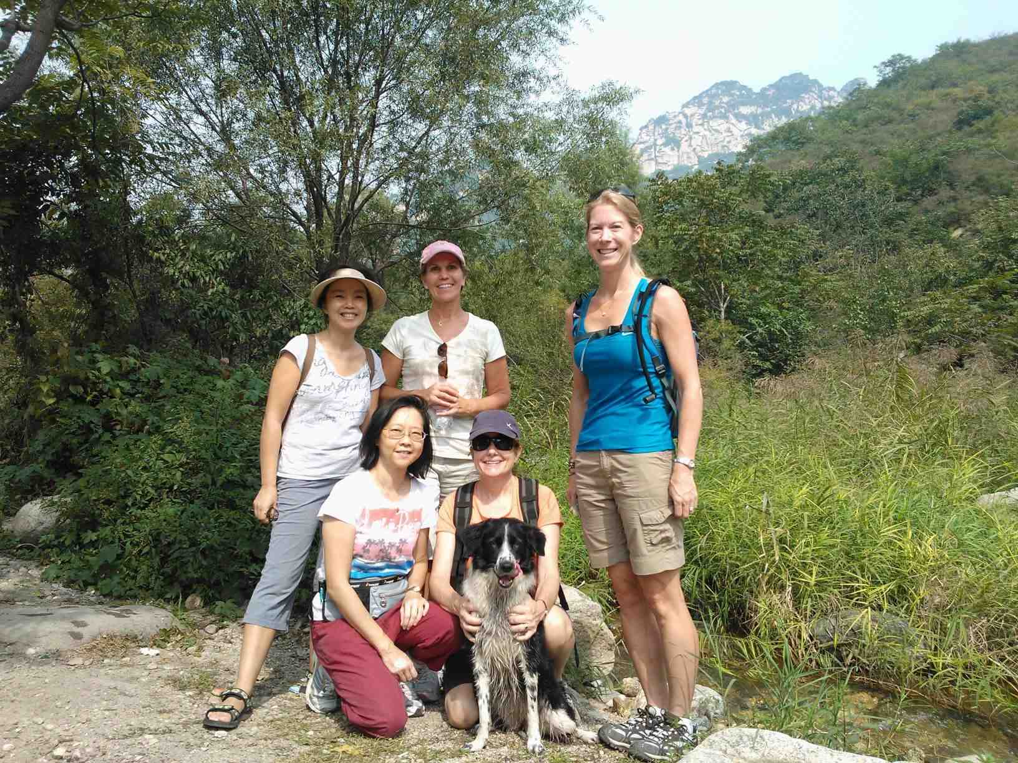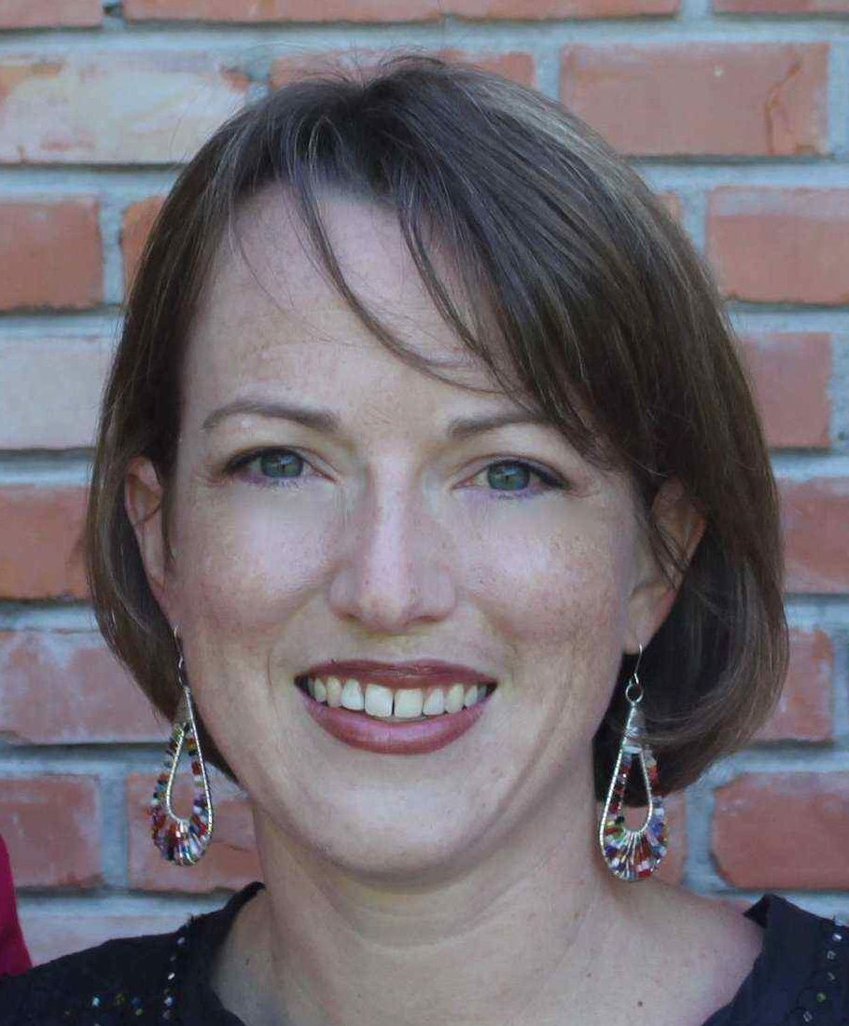

**ENCOURAGMENT TEAM MEMBERS NEEDED!!**

Has the Lord gifted you with the talent of being able to encourage others? If that’s you contact Rachel Heffield at [bjexpatcounselor@gmail.com](mailto:bjexpatcounselor@gmail.com). She is looking for Encouragement Team Members to minister to ladies and their families who may be facing surgery, having a baby, suffering from illness or loss and are in need of extra support.

If you or someone you know are in need of encouragement and support, please contact Rachel. She’d love to hear from you.

CCC Women's September outing: hiking at Intelligence Valley

On September 20th, five ladies from CCC and one dog journeyed to the Miyun area and enjoyed great fellowship, exercise and beautiful scenery at Intelligence Valley.  The hour car ride each way was just more time to get to know each other.  The hike meandered along a stream that had been dammed to create various pools and we enjoyed lunch while our canine companion frolicked in the water before we hiked back downstream to our starting point.  We doubt we increased our intellectual capacity but we enjoyed a lovely day together. Hike participants were Wendy, Kathryn, Siu Ping, Nayree, Julianne and Kathryn's dog Sadie. (Wendy Beeman, pictured in blue)

UPCOMING EVENTS!!!! SAVE THE DATE!

Oct 10 - **Did you know you are being prayed over?** We have a prayer ministry underway and want you to know that our team prays for you! The Women’s Ministry Prayer Team would like you to join us and pray. Please come to our first by-monthly meeting at **10:00am** at the home of Nayree Davis. This fall we will meet every other week during the day, then, every other week in the evening to accommodate your schedule at one of those times. October 10th there will be a brief presentation about the spiritual discipline of prayer. Contact Nayree at: [bnaadavis@yahoo.com](mailto:bnaadavis@yahoo.com) or Darla Gammons at: [darlakkg@yahoo.com](mailto:darlakkg@yahoo.com) for more information or to RSVP for the 10th.

Oct 23 – **New studies commencing**. See Page 1 of this newsletter!

Nov 1 - **Hutong Cuisine CCC Chinese Cooking Class**: a fun day of fellowship, cooking and enjoying a feast!

Depart at 9am from Pinnacle Plaza Starbucks, return around 2:30 (or you can meet us there). Price depends on number of signups but cost should be 200-300 RMB.

Limited to 20 so don't delay signing up. RSVP by October 23. We will need a few volunteers for drivers/vehicles. To reserve your spot contact Wendy Beeman at wendybeeman@hotmail.com.

Nov 30 - Start your Christmas shopping early with a trip to the **Pearl Market** and an inexpensive but yummy **Chinese lunch**. Meet at 9:30am at Pinnacle Plaza Starbucks.  Back by 3pm.

We will need other volunteers to have their cars available to help transport, so if you can help with this, please let me know. Also, please let me know if you would like me to schedule an evening activity because daytime doesn't work for you.  Contact me at [wendybeeman@hotmail.com](mailto:wendybeeman@hotmail.com).

“If my people, who are called by my name, shall humble themselves and pray, and seek my face, and turn from their wicked ways; then I will hear from heaven, will forgive their sin and will heal their land.” 2 Chronicles 7:14

For several years, I have been struck by the magnitude of this invitation by the God of the universe to meet with Him and to receive a response from heaven. As a believer, prayer is a part of life, but if I’m honest, it often looks pretty similar to thinking or even worrying about something without much thought to what’s happening. As I look at this verse, I’m reminded that taking full advantage of the invitation involves the following- humility, making time (or brain space), giving attention, and responding with obedience.

Over the past year, I’ve had opportunity to see vividly the beauty of this invitation and watching Him respond. Several friends in my community have made a point to gather to pray before work a couple of mornings a week. We pray for each other, for specific needs, and we spend a lot of time asking our Father what He wants to do in us and in our community. For me, gathering with one or more others allows me to be present and attentive to this divine meeting and not let it get lost in the clutter of my day. In response, we “hear from heaven”. A visible result has come in the form of seeing 10 + people who were beginning to explore faith, now professing a relationship with the Father and growing deeper in the Word and in fellowship. Additionally, although we know He promises us forgiveness and healing, gathering with others allows us to experience this in a more tangible fashion. We are promised that God is uniquely present with us when two or more are gathered (Matt. 18:20). As we seek His face, the Holy Spirit can intercede for us when we don’t know what to pray, and may give us insight into how to pray for and speak to one another.

These reminders have increased my passion to see others being intentional about praying together for one another and our community. Here at CCC, I’m excited to see movements of prayer and look forward to seeing what the Father has for us as a community, for our families, and for those He may yet bring to Himself here. There’s no magic in the location, so if you’d like to find one or two others to have coffee, or walk dogs while you pray, He is there. The women’s ministry prayer team will be gathering every other week. You’re also invited to join others here in the youth room Saturday evening at 8:30 pm or in the Lounge Sunday morning before worship at 9:00 am. **Rachel Heffield**

**CONTACT US!**

**Director of Women’s Ministries:** Iris Lowder: [irisnprc@securenym.net](mailto:irisnprc@securenym.net)

**Events and Team Co-ordinator:** Rhonda Ausk

[rhonda@auskinternational.com](mailto:rhonda@auskinternational.com)

**Mandarin Women’s Leader:**

Joanne Qian

[Jqian2001@yahoo.com](mailto:Jqian2001@yahoo.com)

**Specific Prayer Request?**

Nayree Davis

bnaadavis@yahoo.com

**Need Support & Encouragement?**

Rachel Heffield

bjexpatcounselor@gmail.com

**Wish to help with Special Events?**

Anna Yuet Wah Leung

annawleung@yahoo.com

**Missions:**

Is this you?

**Communications:**

Eleanor Lyons

eleanor.lyons@me.com

**Want to be involved in Drama?**

Kathryn Westberg

[kbwestberg@hotmail.com](mailto:kbwestberg@hotmail.com)

**Do you have a talent in Church Enhancement?**

Ann Locher

[tennismomlocher@gmail.com](mailto:tennismomlocher@gmail.com)

**Bible Study Fellowship Teaching:**

Angie Schlieff

maschleiff@gmail.com

**www.capitalcommunitychurch.org**