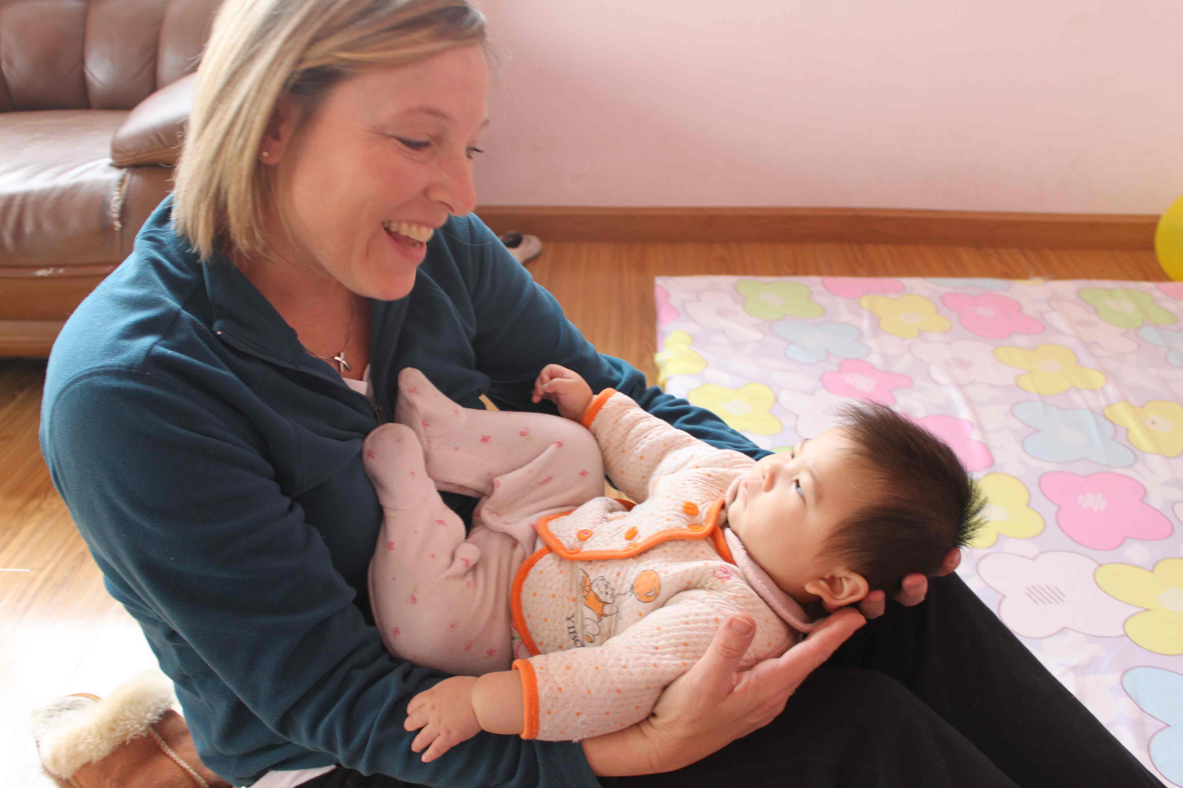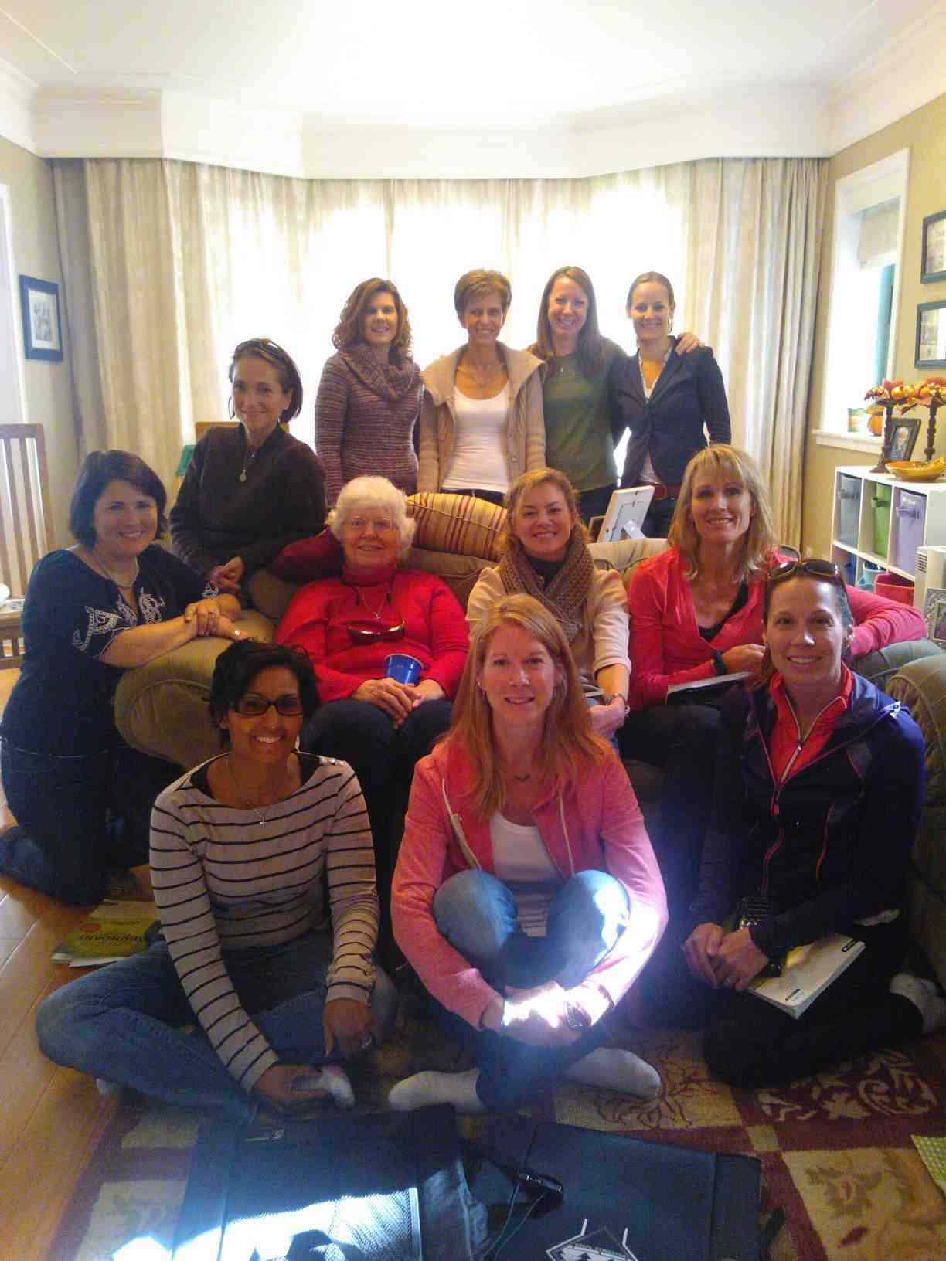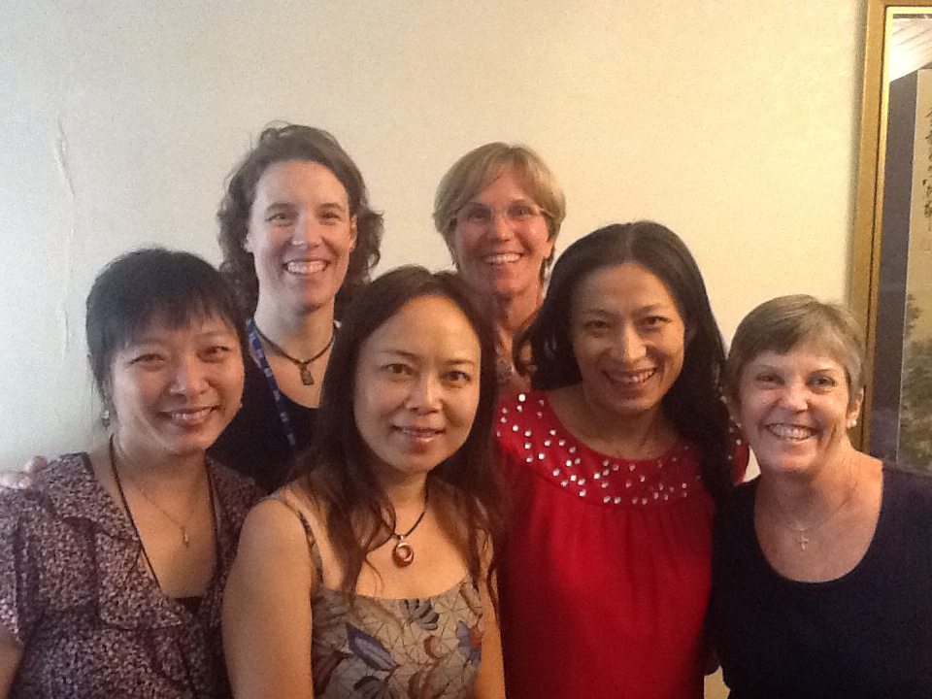

God loves stories – and the Christmas story is one of His best. All the majesty of heaven was sent to earth in a baby born in a manger. He loves showing up in unexpected places. I am praying for you that He makes Himself more real to you this Christmas in unexpected ways. Let’s not miss a thing!! Iris Lowder

Don’t miss this opportunity to share the real meaning of Christmas with local friends!

‘Miracle of Christmas’ by John MacArthur is written in simplified Chinese, legally published in China and clearly shares the Good News. These little books make a wonderful gift. Available for purchase at the Women’s Christmas lunch today and also at church in the coming weeks for 20RMB each!

**Getting Connected in Compassion!**

Beth Canterberry (pictured here with a beautiful bundle) is our Missions Team leader and has connected CCC Ladies with great giving opportunities to reach out to our local community such as:

* Sharing Thanksgiving celebration with local university students

* Christmas Gifts for New Hope Foster Home Nursing Staff

* Volunteering at a local foster home.

If you feel called to volunteer your time to any service projects that Beth is co-ordinating, please contact her at njheeler@aol.com.

Wendy Beeman (pictured below 1st row center) shares about the Tuesday morning group, “we recently finished The Prodigal God and are now studying Faithful, Abundant and True.  This is an amazing group of women and I'm blessed to walk alongside them as we seek to draw nearer to our Lord”

***“I encourage every woman in CCC seize the opportunity to join a small group.  I was thinking about it for more than a year.  Until one day I decided that I just have to do it.  This was how I started my spiritual journey with this lovely group of ladies.  The most encouraging thing is the depth of the issues we discussed and the genuine love and support we experienced from each other.  I would not have touched those issues in my life nor think too deeply that I have an issue.  It was through the studies, prayers, and the spiritual accountability partner that I grew to a deeper understanding of myself and my Lord.  I hope more of you may be blessed by a small group that can take you through the challenge of life in Beijing and find refreshing comfort in sweet fellowship with other women.”  Caroline Huang of the Spiritual Steps Group***

Bible Study Reflections . . .

December 2012

**WANT TO GET CONNECTED?**

Contact Iris Lowder for information about groups on irisnprc@securenym.net

**G E T C O N N E C T E D A T C C C !**

‘Dear friends, since God loves us that much, we surely ought to love each other. No one has ever seen God. But if we love each other, God lives in us, and his love has been brought to full expression through us.`

NLT 1 John 4:11-12

Time for Reflection . . . and a cup of coffee!

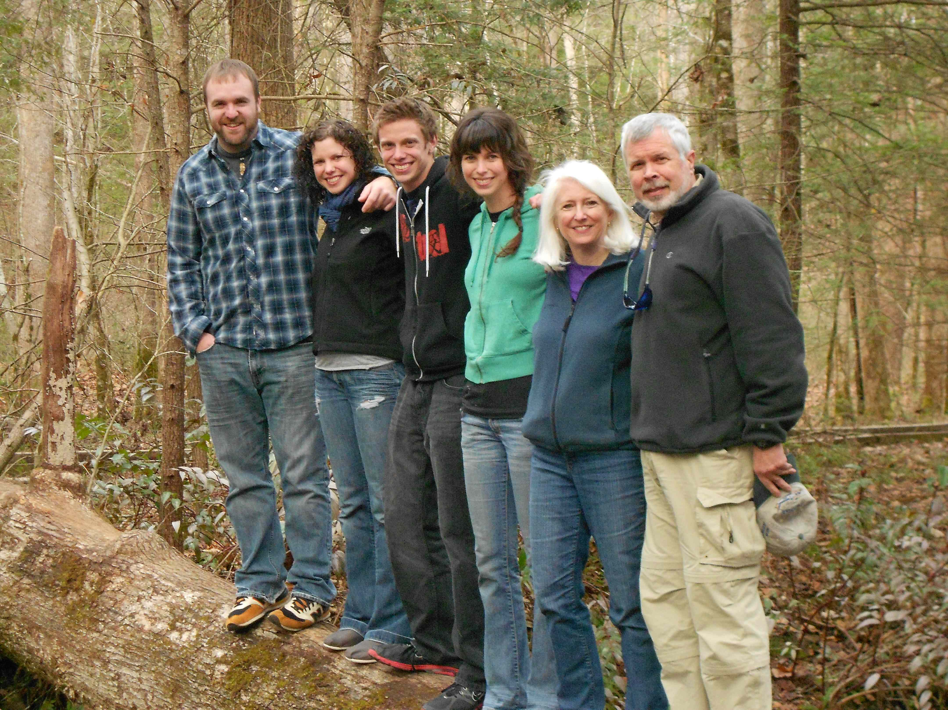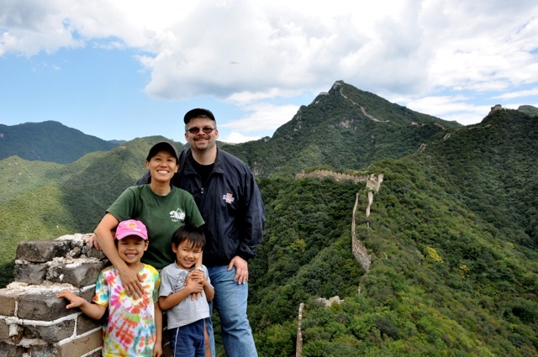

UPCOMING EVENTS!!!! SAVE THE DATE!

**Dec 2** - **Women’s Christmas Lunch** **today**!!! Let the men enjoy time with the kids whilst you come to Wendy Beeman’s House, 1053 (B Section) Yosemite at 12:30pm to share in Christmas lunch and to hear some ladies share about how they keep the ‘Christ in Christmas’.

**Dec 5, 12** – **Prayer Meetings** 11am at Beijing Riviera Apartment A127. Contact Nayree Davis at bnaadavis@yahoo.com

**Jan 8** - **‘More than just a good bible study girl?**’ by Lisa Terkeurst commences Tues mornings led by Wendy Beeman at Beijing Riviera #402 (home of Carrie Pashke). Please RSVP Wendy at wendybeeman@hotmail.com

**Jan 15** - **‘One in a Million!’** bible study by Priscilla Shirer commences Tues 6:30pm to 8:30pm (7 weeks) led by and at the home of Rhonda Ausk (82-01 LaGrande Villa). Please RSVP Rhonda at [rhondakayausk@yahoo.com](mailto:rhondakayausk@yahoo.com)

**Jan 15** - **‘Battlefield of the Mind’** bible study by Joyce Meyer commences Tuesdays 12:30 – 2:30pm led by Kathryn Westberg and Eleanor Lyons at the home of Kathryn, 1223 (B Section) Yosemite. Please RSVP Kathryn at [kbwestberg@hotmail.com](mailto:kbwestberg@hotmail.com)

**Jan 17** - **Potluck Lunch and Games** at Wendy Beeman’s House 11-3pm.  Potluck lunch and games at Wendy Beeman's (Yosemite 1053-B section)  Bring a salad or dessert to share.  I will make a pot of soup.  Enjoy food, fun and fellowship on a cold January day. Contact [wendybeeman@hotmail.com](mailto:wendybeeman@hotmail.com) to let me know you plan to come.

**Getting to know you …**

Hi!  I am Judy Burrows and I am originally from Newark, Delaware, near Philadelphia in the U.S. I have been happily married to Jim for over 30 years now.

We have 3 grown children- Bethany, age 28, who is married to Job and lives in Chicago, Rebekah, 26, who is in graduate school in Pittsburgh and Jason who is 19 this month and a freshman in college, also in Chicago.  We have recently become empty nesters after spending 29 years raising our children. However we have been saying goodbye to our children for over 10 years now since our oldest left the nest.  We miss our kids but I think we are learning to adjust to our new season.

I became a believer in Jesus in 1973 at a Billy Graham movie.  After college I joined a ministry group that I have been with for over 35 years now.  We were first in college ministry, then overseas representatives in Tokyo Japan for 9 years, then in Little Rock, Arkansas with FamilyLife for 12 years and now here in China for the last 3 years. We have been given the privilege, task and stewardship of starting FamilyLife here in China.  Jim and I get to work together training nationals and helping to resource the Chinese with helpful marriage and family resources.  CCC is a great home church for us and we greatly enjoy the relationships, worship and teaching here. I think I am known here as being " the lady with the white hair". So look for me near the church library as I serve as church librarian and let me know if I can help you find a book or resource.

“and He made from one man every nation of mankind to live on all the face of the earth, having determined their appointed times and the boundaries of their habitation, that they would seek God, if perhaps they might grope for Him and find Him, though He is not far from each one of us; ’” Acts 17:26-28

There are no “ooops” with God. Living in Beijing can sometimes cause me to question God (of course, living anywhere probably would) when things do not go the way I hope. There are days when the frustration mounts - snarling traffic, jostling crowds, pervasive pollution, bouts of sickness, constant challenges of working with the system - make it easy to question God, “Are you sure I am supposed to be here?”

Yet God has given us an incredible word in Acts 17. His answer is an unequivocal, “yes”!

God has “appointed times and the boundaries of (our) habitation,” this means, God has not only ordained the days of my life, He has also determined where I should live those days out. In other words, the fact that we all should find ourselves here in CCC, here in Beijing at this point in history, is no accident. It is the sovereign will of God.

When my heart accepts this reality, I find it is easier to stop “whining”, to stop fighting and kicking. Instead, a calm can settle my soul as I learn to be expectant and attentive. This is because God has promised that this very place that I am in is the very door to seeking Him and to finding Him. Will I stop short outside, pouting and miserable or will I choose to enter through it to find Him?

There is also another way to apply this verse, and that is to see all the people whom I get to interact with as being here by God’s sovereign will too. So what is God’s will for them in putting them here in Beijing, in putting them in my life? It is that they might seek Him and find Him also.

Wait a minute, what does this all mean?

For me, it means that God has perfectly planned for me to be here, and that as I rest in this truth, I can respond to all those challenges with a trusting, thankful heart. This in turn will be used by God (in his humorous and amazing ways) to help another find Him!

Last Sunday (with my husband on yet another trip), I received a message. A friend asked if she could come see me with a friend of hers. I was not quite sure what to make of it, and felt some reluctance at agreeing. But that night, amidst much tears as this other lady recounted about her broken marriage, I could sense God was with us. By the time we said goodbye, she felt she was able to pray to God again, and that she was more hopeful about her future in God.

God is fully committed to us, so much so that He placed us here at this present time. The next time when living in Beijing proves difficult, it is time to remember Acts 17; even as I am sure I will be needing that truth again and again too! (Cat Ho Shull is pictured with her family)

**www.capitalcommunitychurch.org**

**CONTACT US!**

**Director of Women’s Ministries:** Iris Lowder: [irisnprc@securenym.net](mailto:irisnprc@securenym.net)

**Events and Team Co-ordinator:** Rhonda Ausk

[rhonda@auskinternational.com](mailto:rhonda@auskinternational.com)

**Mandarin Women’s Leader:**

Joanne Qian

[Jqian2001@yahoo.com](mailto:Jqian2001@yahoo.com)

**Specific Prayer Request?**

Nayree Davis

bnaadavis@yahoo.com

**Need Support & Encouragement?**

Rachel Heffield

bjexpatcounselor@gmail.com

**Wish to help with Special Events?**

Anna Yuet Wah Leung

annawleung@yahoo.com

**Missions:**

Beth Canterbery

[njheeler@aol.com](mailto:njheeler@aol.com)

**Communications:**

Eleanor Lyons

eleanor.lyons@me.com

**Want to be involved in Drama?**

Kathryn Westberg

[kbwestberg@hotmail.com](mailto:kbwestberg@hotmail.com)

**Do you have a talent in Church Enhancement?**

Ann Locher

[tennismomlocher@gmail.com](mailto:tennismomlocher@gmail.com)

**Bible Study Fellowship Teaching:**

Angie Schlieff

maschleiff@gmail.com